**FABRICATION AND TESTING OF CFRP FOR AERO APPLICATIONS**

**G.PRASANTH M.E Dr.SJ.Vijay.M.E,Ph.D,**

**Dr.S.Venkatachalam.M.E,Ph.D**

**ABSTRACT:**

Carbon fiber reinforced plastic (CFRP) is a composite material prized in aerospace applications for its exceptional strength-to-weight ratio and design flexibility. This paper delves into the fabrication and testing processes crucial for CFRP components destined for use in aircraft and spacecraft.The fabrication section will explore various techniques for creating CFRP structures, with a focus on methods commonly used in the aerospace industry. Techniques such as autoclave curing, resin transfer moulding (RTM), and filament winding will be explained, highlighting their advantages and considerations for achieving optimal results in CFRP components. The testing section will discuss the crucial characterization methods employed to assess the mechanical properties of CFRP laminates relevant to aerospace applications.Throughout the paper, the emphasis will be on the interplay between fabrication techniques and the resulting mechanical properties of CFRP. The goal will be to provide a

comprehensive understanding of how CFRP components are manufactured and evaluated to meet the stringent requirements of the aerospace industry.

**INTRODUCTION:**

The relentless pursuit of efficiency and performance in the aerospace industry has driven innovation in materials science, with carbon Fiber reinforced plastic (CFRP) emerging as a game-changer. CFRP's exceptional strength-to-weight ratio surpasses that of traditional materials like aluminum and steel. This translates to lighter aircraft and spacecraft, leading to significant improvements in fuel efficiency, payload capacity, and overall operational range. Additionally, CFRP offers remarkable design flexibility. Unlike metals, CFRP allows for the tailoring of Fiber orientation and ply stacking sequences within the composite laminate. This enables engineers to optimize the material's properties for specific loading conditions, creating lightweight structures with exceptional strength and stiffness in targeted directions. The remarkable properties of CFRP have led to its widespread adoption across various aerospace applications. However, the successful utilization of CFRP in these demanding applications hinges on two crucial processes: fabrication and testing. Meticulous fabrication techniques are essential for creating high-quality CFRP structures with consistent properties. These techniques involve meticulously laying down carbon Fibers in a specific orientation, impregnating them with a resin matrix, and curing the composite under controlled conditions. Any inconsistencies or flaws introduced during fabrication can compromise the structural integrity of the final component, potentially leading to catastrophic failure. On the other hand, rigorous testing procedures are necessary to ensure that the fabricated CFRP components meet the stringent performance requirements of the aerospace industry.

**Fabrication Techniques for CFRP Aero Structures:** The fabrication of CFRP components for aerospace applications involves a multi-step process that demands precision and control. Here, we will delve into some of the most common techniques employed in the industry:

**Autoclave Curing:** This is a widely used technique where the laid-up CFRP plies are placed within a pressurized autoclave chamber. The chamber applies heat and pressure simultaneously, promoting the curing of the resin matrix and creating a strong bond between the Fibers. The controlled environment of the autoclave ensures consistent consolidation and optimal mechanical properties in the final CFRP component.

**Resin Transfer Molding (RTM):** This technique involves injecting liquid resin into a closed mold containing pre-placed dry carbon Fibers. The resin fills the mold cavity and wets out the Fibers, leading to the formation of the composite structure after curing. RTM offers advantages like good surface finish and the ability to create complex shapes. However, it requires careful design of the mold flow path to ensure complete resin impregnation and avoid voids within the composite.

**METHODOLOGY:**

**Testing Methodologies for CFRP Characterization:**

This methodology outlines the steps involved in fabricating and testing Carbon Fiber Reinforced Polymer (CFRP) laminates for aerospace applications. The specific details may vary depending on the chosen fabrication technique and desired final properties.

**Fabrication**

**1. Material Selection:**

Select CFRP constituents

* Carbon fibers: Choose fiber type (e.g., high-strength, high-modulus), tow size, and surface treatment based on desired properties and application.
* Resin system: Select a resin system compatible with the chosen fibers and offering appropriate processing characteristics (e.g., viscosity, cure temperature) for the chosen fabrication method.

**2. Laminate Design:**

* Design the laminate layup: Specify the stacking sequence, fiber orientation, and number of plies to achieve the desired mechanical properties and structural performance.
* Utilize laminate analysis software (optional) to predict stiffness, strength, and failure modes.

**3. Fabrication Process:**

Common techniques for aerospace CFRP include:

* **Autoclave Prepreg Layup**

Pre-impregnated (prepreg) carbon fiber plies are layered according to the design, followed by vacuum bagging and curing in an autoclave under pressure and controlled temperature

.

* **Out-of-Autoclave (OoA) Techniques**

Various OoA methods exist, such as Resin Transfer Molding (RTM) and Vacuum Assisted Resin Transfer Molding (VARTM), where dry fibers are placed in a mold, resin is infused, and the laminate is cured at lower pressure and temperature.

**4. Curing:**

* Follow the recommended cure cycle for the chosen resin system to ensure proper crosslinking and achieve optimal mechanical properties.
* Monitor temperature and pressure profiles during curing (if applicable) for process control.

**5. Consolidation and Finishing:**

* After curing, remove the laminate from the mold (if applicable) and trim any excess material.
* Depending on the application, surface finishing techniques like sanding or machining might be required.

Carbon fiber sheet with epoxy resin

|  |  |  |
| --- | --- | --- |
| Material | Young’s Modulus (GPA) | Tensile strength (MPA) |
| Corbon fiber sheet | 250 | 4.9 |
| Epoxy resin | 3.5 | 52.2 |

Material properties

**Resin Systems:**

The resin matrix plays a crucial role in binding the Fibers together, transferring loads, and protecting them from environmental degradation. Epoxy resins are commonly used in aerospace CFRP due to their excellent mechanical properties and high strength-to-weight ratio. However, advancements in other resin systems, such as toughened epoxies and thermoplastics, offer potential benefits like improved damage tolerance and faster processing times.CFRP's exceptional properties have revolutionized aerospace design, enabling the creation of lighter, stronger, and more fuel-efficient aircraft and spacecraft. However, its successful utilization relies on meticulous fabrication techniques and rigorous testing procedures. This paper has explored the various techniques employed for CFRP fabrication, highlighting the importance of factors like material selection and process control. Additionally, it has discussed the essential role of destructive and non-destructive testing in characterizing the mechanical properties and ensuring the structural integrity of CFRP components. As the aerospace industry strives for ever-greater efficiency and performance, advancements in both fabrication and testing methodologies will continue to pave the way.

**RESULTS AND DISCUSSION:**

* 1. **Fabrication:**

A fabrication with two plates of orientations [45, 90, 90, 45] and [90, 45, 45, 90] was utilized. Four specimens were then cut from these plates for subsequent impact

testing. Both orientations were subsequently tested by dropping a weight on a single plate at a height of 0.5mm. The impact resulted in energy absorptions of 30.411 and 60.822, measured at drop heights of 0.5mm and 1 meter, respectively. It is important to note that the drop weight remained constant throughout the testing process. However, the energy absorption varied as the height of the specimen was changed.

**IMPACT DROP TEST:**

Four specimens were used in this test at two orientations: 40 degrees (0.5mm and 1m) and 90 degrees (0.5mm and 1m). Tests were then conducted at these orientations.

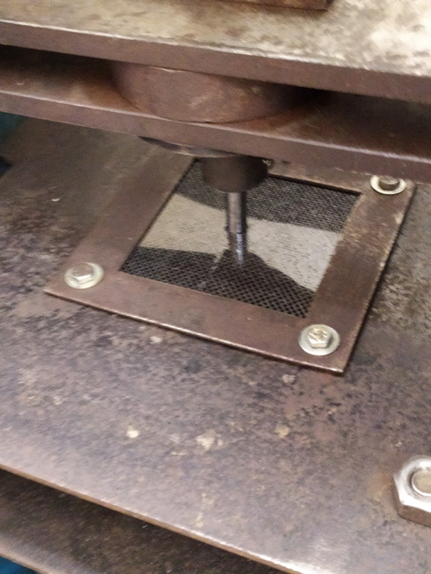

|  |  |  |  |  |
| --- | --- | --- | --- | --- |
| Test no | Acceleration | Velocity | Energy | Displacement |
| Test 1 (0.5mm) | 1128.70 m/sec2 | 4.44 m/sec | 61 J | 56mm |
| Test 2 (1mm) | 1127.75 m/sec2 | 4.43 m/sec | 58 J | 23mm |

Table 4.1 Impact test result

**Test number – 1**

Sampling Rate = 10000 S/s

FSR = 10 V = 40.00 ton

Tare value(Offset): 0.574 ton

Acceleration: 1128.70m/sec2

Velocity:4.44 m/sec

Displacement: 56mm

Energy : 61 J

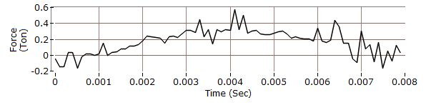

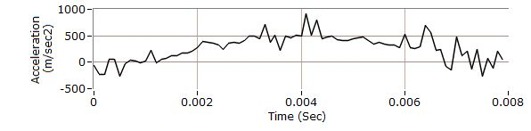

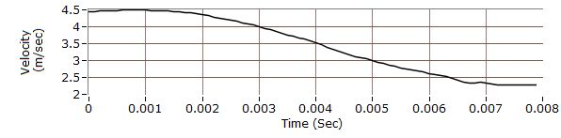

**Test Number: 2**

Sampling rate = 10000 S/s

FSR 10V = 40.00 ton

Tare Value(offset): 0.560 ton

Acceleration: 1127.85m/sec2

Velocity:4.43 m/sec

Displacement: 23mm

Energy : 58J

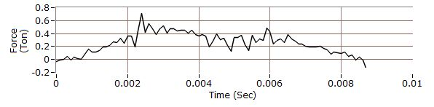

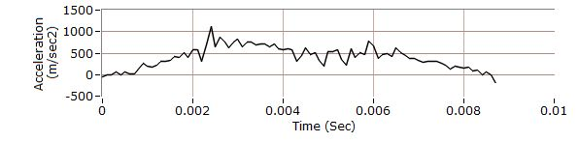

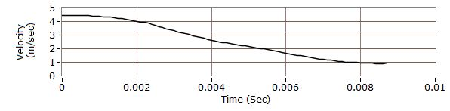

**CONCLUSION**

In this study, the manufacture and testing of carbon fiber-reinforced polymers (CFRP) were successfully investigated. Critical features, such as impact test (energy), were evaluated through these tests. Two orientations were tested by dropping a weight on a plate from a height of 0.5mm. The impact resulted in an energy absorption of 30.411. The test was repeated at a height of 1 meter, achieving an energy absorption of 60.822. Notably, the drop weight, height, and absorbed energy all varied based on the two different drop heights employed. It is well-known that Carbon Fiber Reinforced Polymer (CFRP) has revolutionized the aerospace industry due to its exceptional combination of high strength, low weight, and excellent fatigue resistance. The impact drop test was conducted at angles of 45 and 90 degrees. It is important to note that the specimen did not break at a drop height of 0.5mm (where the absorbed energy was 30.411).

**REFERENCES**

[1] **Lu, J., Zhang, H., Ren, G., Chen, Y., Luo, L., Cai, H., ... & Zhao, X. (2024).** A comparative study on the oxidation behavior and failure mechanisms of conventional NiCoCrAl alloy and in-situ composite AlCoCrFeNi2. 1 eutectic high-entropy alloy at 1300° C. *Composites Part B: Engineering*, *269*, 111097.

[2]**Zhang, Mingyu, Lei Chu, Jiahua Chen, Fuxun Qi, Xiaoyan Li, Xinliang Chen, and Deng-Guang Yu.** "Asymmetric wettability fibrous membranes: preparation and biologic applications." *Composites Part B: Engineering* (2023): 111095.

[3] **Jakobsen, J., Endelt, B., & Shakibapour, F. (2024).** Bolted joint method for composite materials using a novel fiber/metal patch as hole reinforcement—Improving both static and fatigue properties. *Composites Part B: Engineering*, *269*, 111105.

[4] **Mofakhami, E., et al.** "Effect of fibre concentration on the mechanical properties of welded reinforced polypropylene." *Composites Part B: Engineering* 269 (2024): 111111.

**[5] Mishra, K., & Singh, A. (2024).** Effect of graphene nano-platelets coating on carbon fibers on the hygrothermal ageing driven degradation of carbon-fiber epoxy laminates. Composites Part B: Engineering, 269, 111106.

**[6] Cintra, G. G., Vieira, J. D., Cardoso, D. C., & Keller, T. (2024).** Novel multi-crack damage approach for pultruded fiber-polymer web-flange junctions. Composites Part B: Engineering, 269, 111102.

**[7] Yilmaz, S., Theodore, M., & Ozcan, S. (2023**). Silicon carbide fiber manufacturing: Cost and technology. Composites Part B: Engineering, 111101

**[8] He, Y., Tian, G., Pan, M., & Chen, D. (2014).** Impact evaluation in carbon fiber reinforced plastic (CFRP) laminates using eddy current pulsed thermography. Composite Structures, 109, 1-7

**[9] E. Kirkby, R. de Oliveira, V. Michaud, J.A. Månson ⇑,** Impact localisation with FBG for a self-healing carbon fibre composite structure.

**[10] Al-Lami, A., Hilmer, P., & Sinapius, M. (2018)**. Eco-efficiency assessment of manufacturing carbon fiber reinforced polymers (CFRP) in aerospace industry. Aerospace Science and Technology, 79, 669-678.

**[11] Li, D., Yang, B., Zhang, J., Jin, L., & Du, X. (2023).** Effects of Concrete Strength and CFRP Cloth Ratio on the Shear Performance of CFRP Cloth Strengthened RC Beams. Buildings, 13(10), 2604.

**[12] Ding, J., Cheng, L., Chen, X., Chen, C., & Liu, K. (2021).** A review on ultra-high cycle fatigue of CFRP. Composite Structures, 256, 113058.

**[13]Jianwu Zhou , Binbin Liao , Yaoyao Shi** ,Yangjie Zuo , Hongliang Tuo **, Liyong Jia** e Low-velocity impact behavior and residual tensile strength of CFRP laminates

**[14] Zhou, J., Liao, B., Shi, Y, Zuo, Y, Tuo, H, & Jia,** **L.** (2019). Low-velocity impact behavior and residual tensile strength of CFRP laminates. Composites Part B: Engineering, 161, 300-313.

**[15] Samuel, Jebaraj Jeremy Jeba, et al.** "Studies on mechanical properties and characterization of carbon fiber reinforced hybrid composite for aero space application." Materials Today: Proceedings 47 (2021): 4438-4443